Chapter 6, Problem 60.

In the circuit of Fig. 6.82, i_{o}(0) = 2 A. Determine i_{o}(t) and v_{o}(t) for t > 0.

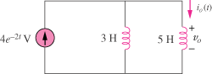
4e^{–2t} A

Figure 6.82
For Prob. 6.60.

